HOW TO CREATE A COMBINATION FIELD
WITH LABEL MATRIX

- Specify Combination as the image origin type from the data tab

- Click the Use Wizard button on this screen to let the Combination Wizard guide you through the setup. The Combination Wizard steps you through the process of adding a combined image to your label; it helps you build an expression. As long as the Add another data origin to combined image option is checked, you can select and set up data origins to add to the expression.

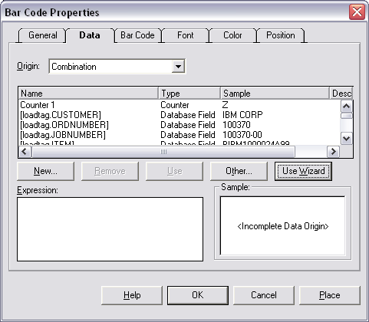

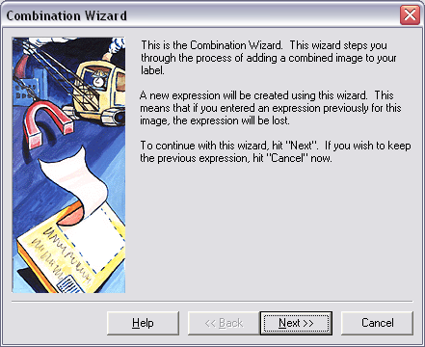
Click the next button

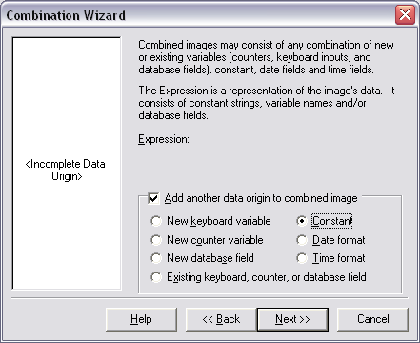

The Combination Wizard steps you through the process of adding a combined image to your label; it helps you build an expression. As long as the Add another data origin to combined image option is checked, you can select and set up data origins to add to the expression.

Once you choose your first field type, click the next button.
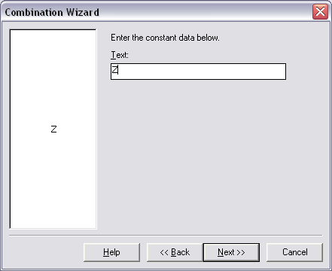
Type in your text if using a constant field
Click Next

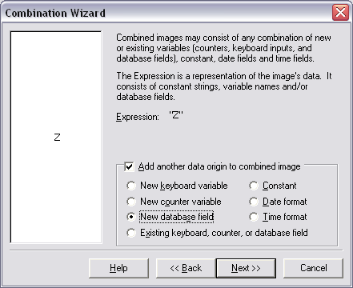

As long as the Add another data origin to combined image option is checked, you can select another data origin to the expression.

Once you choose your next field type, click the next button.

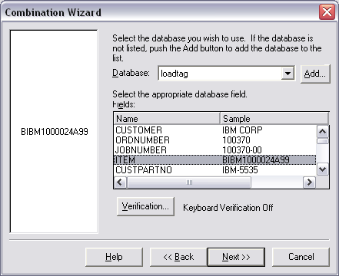

Once you select the database choose the field from that database.

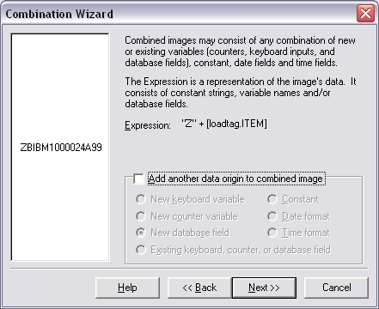

When you are finished building your expression, de-select the Add Another…option to gray out all choices and click Next to view your completed expression. If you decide at this point that you want to change any part of the expression, click the Back button located at the bottom of the dialog to go back and make changes.
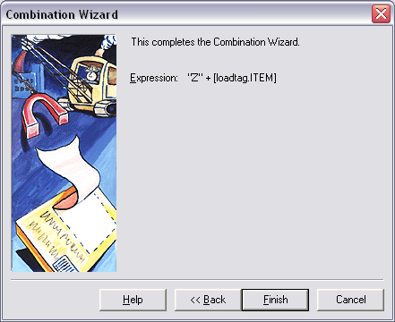

After choosing Finish to end the wizard, the screen will show you a sample of the field which you created.

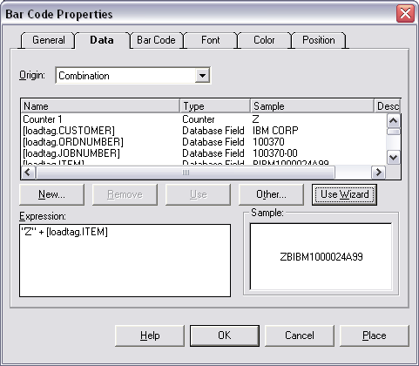

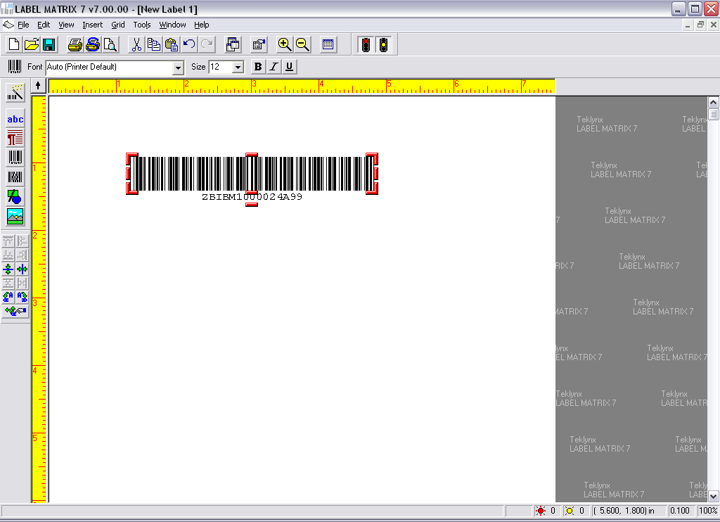

As you can see the barcode above was created by using the combination wizard. We first chose to add the Letter “Z” before the item database field. Each label will therefore print the “Z” as a prefix to the item field on each label.

Congratulations! You have just completed the setup of a combination field.

